**IDFC FIRST BANK:-**

* IDFC (Infrastructure Development Finance Company) FIRST Bank is a private sector bank in India, formed by the merger of IDFC Bank and The First Bank of India in 2019.

IDFC Bank was founded in 2004 as the infrastructure.

* Development Finance Company (IDFC). It was the first non-banking financial company (NBFC) to be granted a banking license by the Reserve Bank of India (RBI) in 2014. The First Bank of India was founded in 1994.
* The market capitalization of IDFC FIRST Bank as of September 8, 2023 is ₹63,773.78 crore. The bank's market capitalization is expected to continue to grow in the coming years. This is due to the bank's plans to expand its digital banking capabilities and its focus on wealth management. The reason why I chose this stock is because this range mid-cap can grow faster than stocks that have 5-7 lakh cr mapket cap, these will now growth with slow-steady speed level.

**ALL THE INFORMATION HAVE GATHERED FROM THE BANKS ANNUAL REPORT 2022-2023.**

**This analysis is as of 11-09-2023**

**BUSINESS MODEL: -**

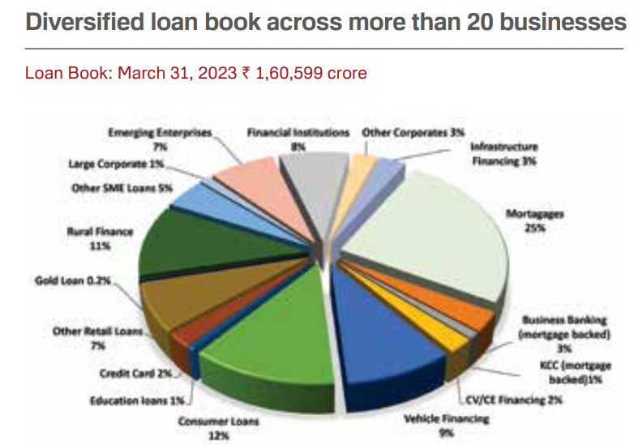

**THE MOST IMPORTANT PARAMETER TO BE ANALYSED IN BANKING SECTOR IS “CASA RATIO” AND “NPA RATIO”: -**

**CASA ratio of this bank:-**

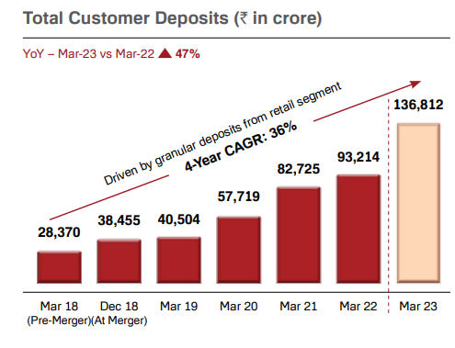

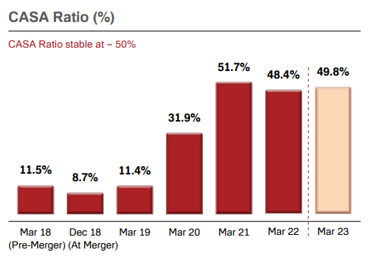

Ref above diagrams: - As of March 31, 2023, the CASA ratio of IDFC FIRST Bank is 49.77%, and the **industry CASA average 38%.** This means that 49.8% of the bank's deposits are from current and savings accounts (CASA), which are considered to be more stable than other types of deposits.

A high CASA ratio is a good sign for a bank, as it indicates that the bank has a strong deposit base and is less reliant on volatile sources of funding, such as short-term loans.

The CASA ratio of IDFC FIRST Bank has been steadily increasing over the past few years. This is due to the bank's focus on retail banking and its efforts to attract more CASA deposits.

The CASA ratio is an important indicator of a bank's financial health. A high CASA ratio can help a bank to weather economic downturns and to maintain its profitability.

**BANK FOCUSES MORE ON RETAIL BANKING RATHER THAN WHOLESALE BANKING: -**

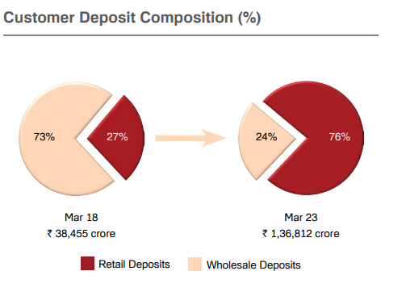

Ref above diagrams: - This is due to the bank's focus on retail banking and its efforts to attract more CASA deposits. The bank has a strong focus on retail banking and has been expanding its digital banking capabilities.

Retail banking customers are typically individuals and small businesses, which are less likely to default on their loans than large corporate borrowers.

Retail banking customers are typically individuals and small businesses, which are less likely to default on their loans than large corporate borrowers. **Also, the interest at which retails are given loans is higher than the corporate loan.**

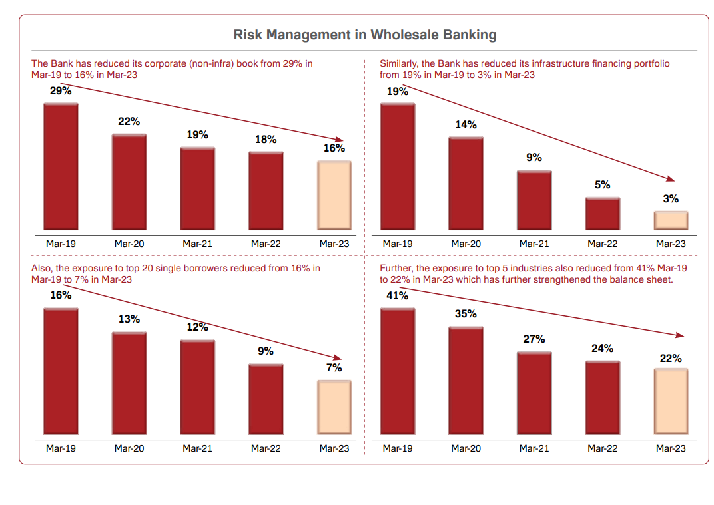



**ABOUT NPA and GPA:-**

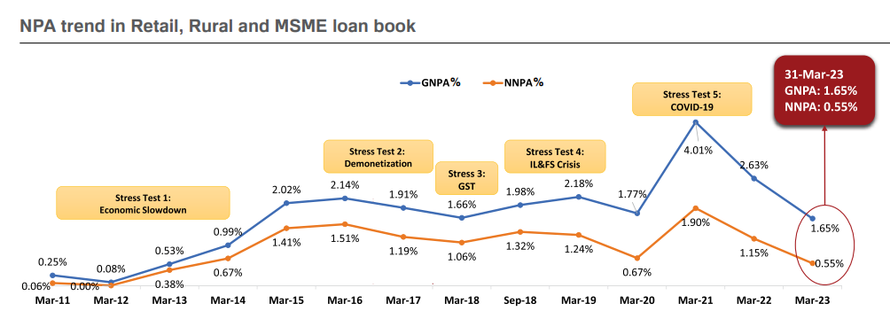

The gross non-performing assets (NPA) is the total amount of loans that are not being repaid by borrowers. It is calculated as a percentage of the total outstanding loans.

The net non-performing assets (NPA) is the amount of gross NPAs after deducting the provisions that the bank has made against those loans. Provisions are amounts that the bank sets aside to cover the expected losses on its NPAs.

So GNPA – NNPA = provisions that the bank has made against its NPAs.

**As you can see on the above figure:-**The GNPA of IDFC FIRST Bank has been declining in the past few years. This is a positive sign, as it indicates that the bank is managing its assets well and is lending to borrowers who are less likely to default.

The NNPA of IDFC FIRST Bank has also been declining in the past few years. This is also a positive sign, as it indicates that the bank is making provisions against its NPAs and is taking steps to recover the loans.

The GNPA and NNPA have stayed low at around 2% and 1% since the last 13 years, through multiple crises such as slowing economy, demonetisation, GST implementation, IL&FS crisis. Accept during covid time**. Also the industry average gross non-performing asset (GNPA) ratio for private banks in India was 4.5% as of March 31, 2023**. **The industry average net non-performing asset (NNPA) ratio was 2.5%.**

**BANK PCR: -**

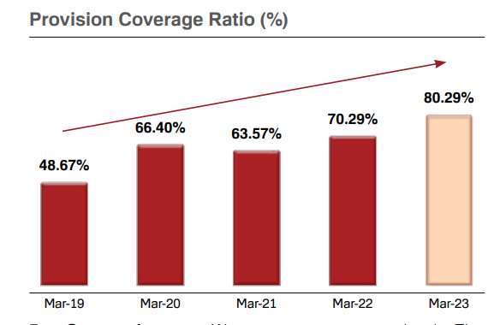

Provision Coverage Ratio = Total Provisions / Total NPAs

The RBI (Reserve Bank of India) prescribes a minimum provision coverage ratio of **70%** for all banks. This means that banks are required to have enough provisions to cover at least 70% of their NPAs.

A high provision coverage ratio indicates that the bank is well-prepared to deal with its bad loans and is less likely to default on its obligations.

As you can that the PCR of IDFC FIRST BANK has been increasing , so this is a positive sign.

**ABOUT CEO: -**

The current MD and CEO of IDFC FIRST Bank is V. Vaidyanathan. He is a veteran banker and entrepreneur with over 30 years of experience in the financial services industry. He was the Managing Director and CEO of Capital First, which was merged with IDFC Bank in 2018 to form IDFC FIRST Bank.

Vaidyanathan is a graduate of the Indian Institute of Technology, Madras and the Indian Institute of Management, Ahmedabad. He began his career with Citibank in 1990 and held various positions in the bank, including Head of Corporate Banking and Head of Retail Banking. He joined ICICI Bank in 2000 and was responsible for setting up and leading the bank's retail banking business.

In 2009, Vaidyanathan founded Capital First, a non-banking financial company (NBFC) that focused on providing financial services to small businesses. He grew Capital First into a leading NBFC and it was listed on the Bombay Stock Exchange in 2015.

Vaidyanathan is a board member of several organizations, including the National Stock Exchange of India and the Indian Banks' Association. He is also a member of the Prime Minister's Economic Advisory Council.

Vaidyanathan is known for his innovative approach to banking and his focus on customer service. He is also a strong advocate for financial inclusion and has worked to make banking services more accessible to the underserved.

Under Vaidyanathan's leadership, IDFC FIRST Bank has grown into one of the leading private sector banks in India. The bank has a strong focus on retail banking and has been expanding its digital banking capabilities. IDFC FIRST Bank has also been active in the social banking space and has launched several initiatives to promote financial inclusion.

**CEO COMMITMENTS: -**

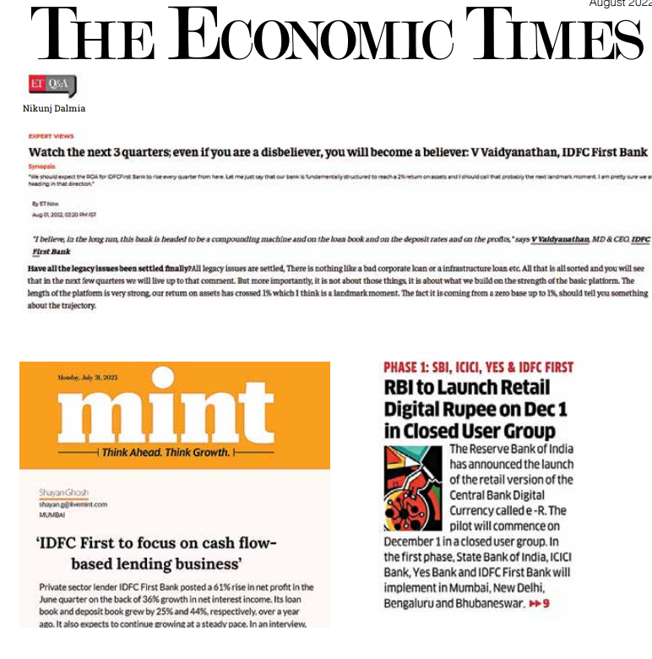



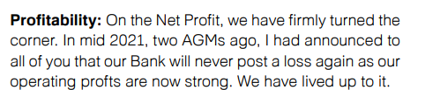.



**BANKS cost to income ratio: -**

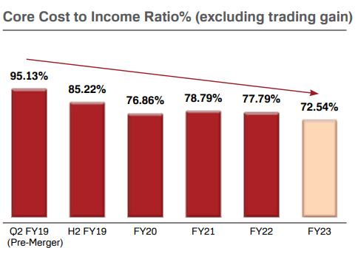

Cost-to-Income Ratio = Operating Expenses / Operating Income.

The CIR is expressed as a percentage. A lower CIR indicates that the company is using its resources more efficiently.

Though company has high CIR, but we can see that its declining year on year. So it a positive sign.

**Our Cost to Income ratio as well as ROE is clouded**

**because of two issues at our Bank. One, our Bank is**

**paying an interest of around 9% on legacy liabilities of**

**` 17,000 crores which we will replace at around 6.5%**

**with incremental deposits. Further, the bank has launched many new businesses such as home loans, credit cards, gold loans, which are currently loss-making because of nascent stage, but will all turn profitable with scale. As this scale phenomenon plays out, the Cost to Income ratio will come down gradually and the true picture of our profitability will emerge**

**DIVIDEND YEILD%: -**

This bank has 0% dividend yield, this is good according to me because instead of paying dividends to its shareholders, it would be better to invest that money in the own company for its expansion and growth.

In case of this bank it invests that money opening new branches and different type of loans. **THIS is called actual compounding in stocks.**

**STOCK VALUATION: -**

**The price-to-earnings ratio (PE ratio)** is a financial ratio that shows the relationship between a company's stock price and its earnings per share (EPS).

It is calculated by dividing the current stock price by the EPS.

the stock PE ratio of its TTM (trailing twelve months) is 23.26, and the sector PE ratio is 24.24 according to moneycontrol.com,

Also when calculated the average PE ration of top private banks it was coming near 28%. So buy this I conclude that this stock is neither overvalued nor undervalued.

**The price-to-book ratio (PB ratio)** is a financial ratio that compares the market value of a company's stock to its book value per share. It is calculated by dividing the current stock price by the book value per share.

The book value per share is the company's net assets divided by the number of outstanding shares. Net assets are the company's assets minus its liabilities.

**SHAREHOLDING PATTERN: -**

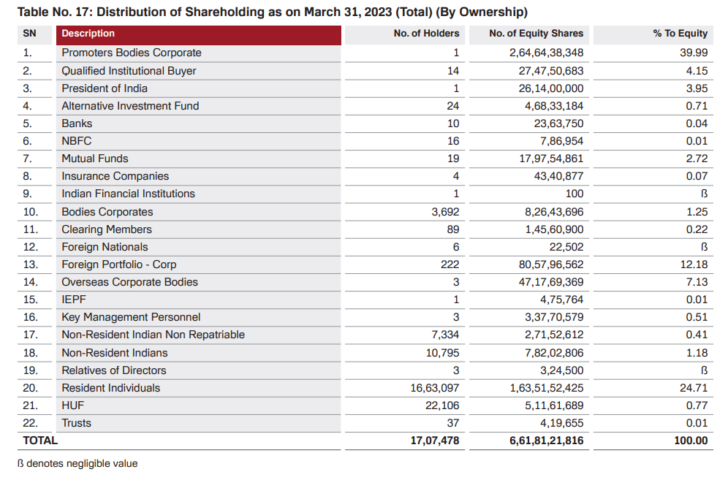

GOOD, as we can that the promoters are having highest percentage of shareholding because this is a professionally owned business not a family-owned business.

**FINANCIAL STATEMENTS OF THIS BANK: -**

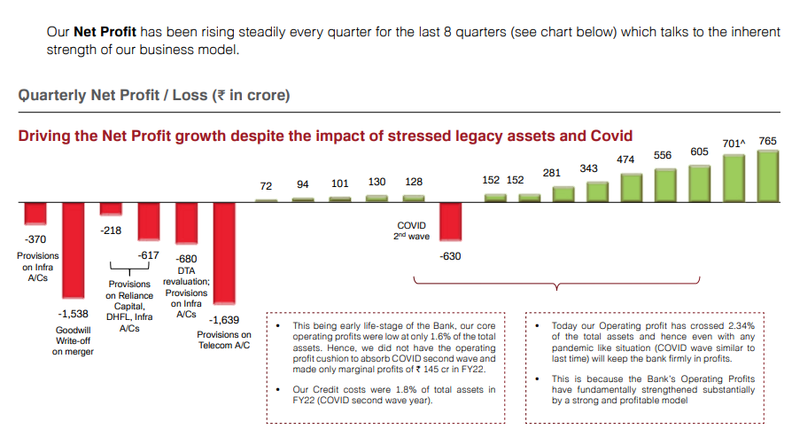

THE financial statements (**balance sheet, profit and loss accout , and cash flow statement )**of this bank is also good.

Also it has **positive free cash flow**

I will add more parameters in this analysis , detail analysis of financial statements. This is just a raw/rough financial statement analysis

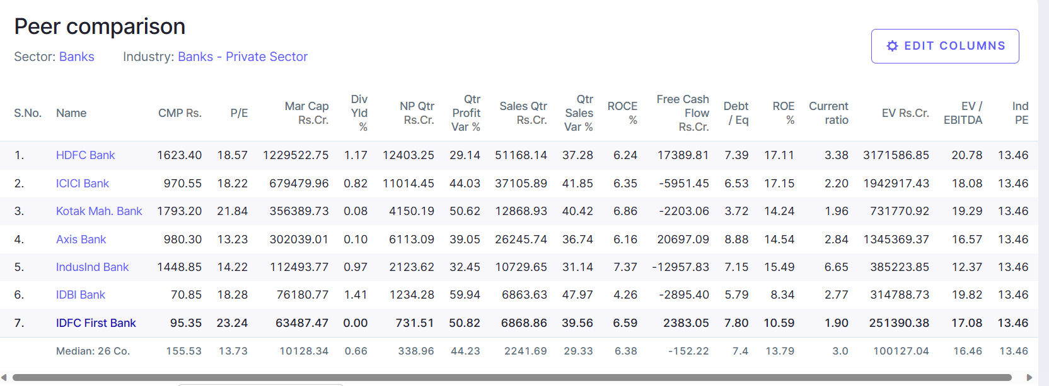

When comparing our profitability with other banks please see our progress in the context that we are practically 5 years old Bank while other banks have been around for 20-30 years